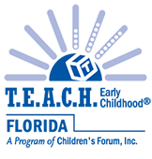

**2024 T.E.A.C.H. Early Childhood® Scholar Evaluation Survey Responses**

(531 scholars responded)

**Demographics of T.E.A.C.H. Scholar Respondents**

**Scholars attended classes at:**

**76%** College/University

**3%** Vocational/Technical School

**21%** Other

**Classes were held:**

**82%** Online

**3%** In a classroom

**15%** Both

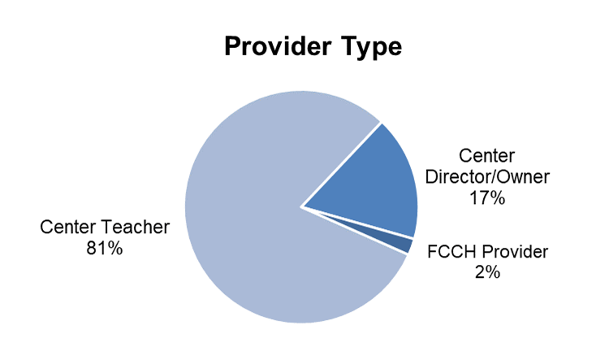

**Regarding their college/training programs, scholars reported:**

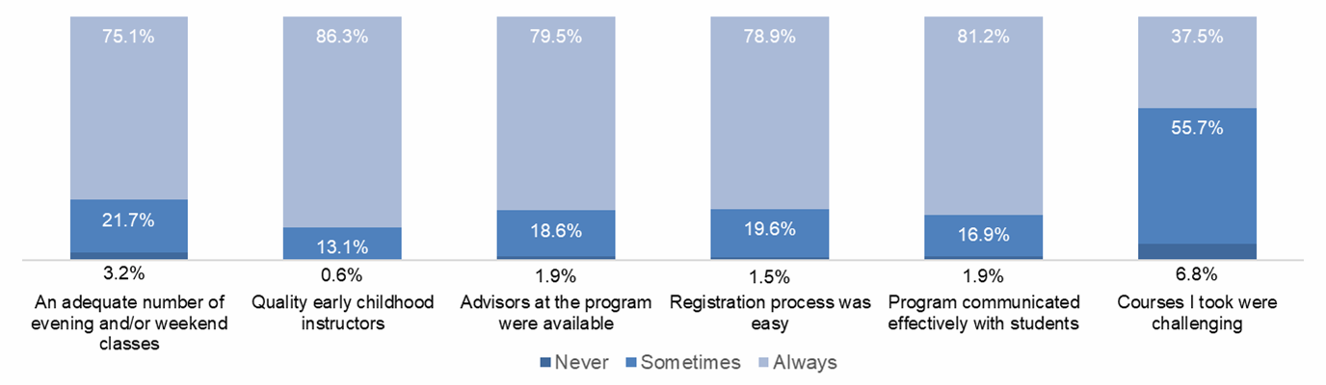

**Satisfaction with the T.E.A.C.H. program**

**99%** graded the T.E.A.C.H. program as excellent (91%) or good (8%)

**99%** would recommend T.E.A.C.H. to other child care workers

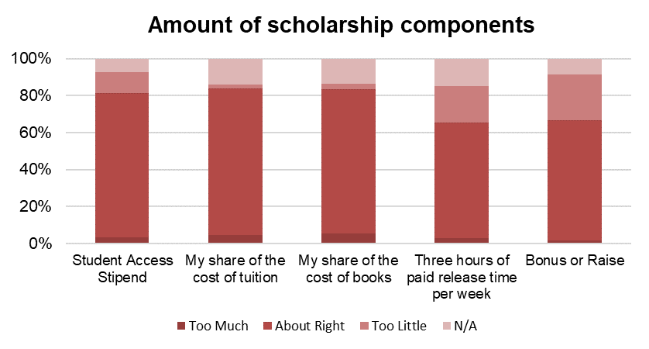**99%** found the T.E.A.C.H. staff and counselor(s) supportive

(93% very, 6% somewhat)

**97%** found their sponsoring child care center supportive

(83% very, 14% somewhat)

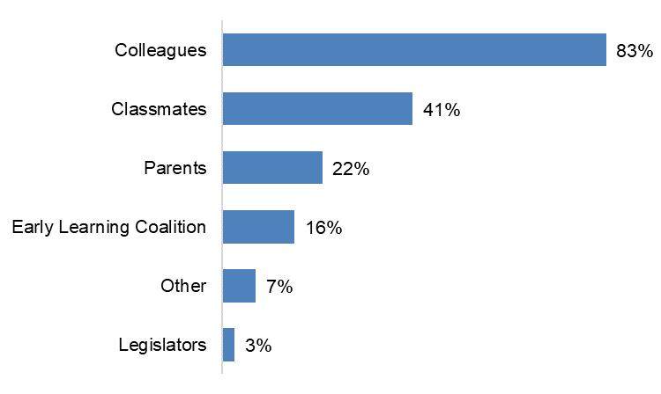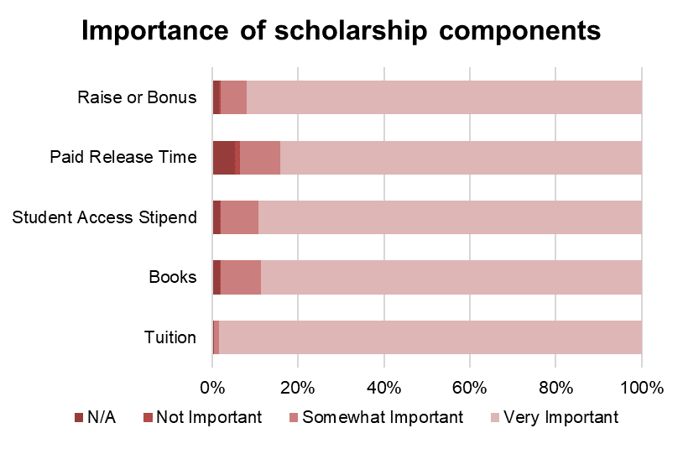

**Scholars spoke with others**

**about their scholarships**

